Project Summary
This project turns CUST's old single-server setup into a modern cloud system with 3 separate microservices, each running in its own Docker container:
- Registration Service → manages students, courses, enrollments
- LMS Service → manages lecture materials, assignments, submissions
- Examination Service → manages exams, results, transcripts
An API Gateway sits in front and routes all requests. Everything is containerized with Docker so it runs the same on any machine.

Step-by-Step Execution Guide
Step 1 — Extract the ZIP
Extract cust-cloud-project.zip to a folder on your Desktop or Documents. You'll get a folder called cust-cloud-project.

Step 2 — Open in VS Code
Open VS Code → File → Open Folder → select cust-cloud-project
You should see this structure in the VS Code file explorer:
cust-cloud-project/
├── services/
├── k8s/
├── distributed/
├── docker-compose.yml ← most important file
└── README.md

Step 3 — Open the VS Code Terminal
In VS Code: Terminal → New Terminal (or press Ctrl+`)

Step 4 — Make sure Docker is running
Before anything, Docker Desktop must be open and running. Check it shows "Engine running" in the bottom left of Docker Desktop.
Verify in the terminal:
docker --version
You should see something like Docker version 27.x.x — if you get an error, open Docker Desktop first and wait for it to start.

Step 5 — Build and Start all containers
This single command builds all 4 Docker images and starts all containers:
docker-compose up --build
What this does: Docker reads docker-compose.yml, builds a container image for each service (registration, lms, examination, api-gateway), then starts all 4 containers connected on the same private network.
First run takes 2–4 minutes (downloading Python base image). You'll see logs streaming from all 4 services. When you see lines like this, everything is ready:
cust_registration | [INFO] Booting worker with pid: ...
cust_lms | [INFO] Booting worker with pid: ...
cust_examination | [INFO] Booting worker with pid: ...
cust_gateway | [INFO] Booting worker with pid: ...

Step 6 — Verify everything is healthy
Open a second terminal in VS Code (Terminal → New Terminal) and run:
curl http://localhost:5000/health
You should see all 3 services showing "status": "healthy". If you don't have curl, open your browser and go to:
http://localhost:5000/health

Step 7 — Test the services via browser
Open these URLs directly in your browser to see live data:
URL | What you'll see
http://localhost:5000/health | Health of all 4 containers
http://localhost:5000/api/registration/students | List of students
http://localhost:5000/api/registration/courses | Available courses
http://localhost:5000/api/lms/materials/CPE4541 | Lecture materials
http://localhost:5000/api/lms/assignments/CPE4541 | Assignments
http://localhost:5000/api/exam/exams | Exam schedule
http://localhost:5000/api/exam/transcript/FA21-BCE-001 | Student transcript
http://localhost:5000/api/dashboard/metrics | Stats from all services

Step 8 — Run the distributed computing modules
Open a new terminal and run each module separately:
Multithreading demo (simulates 35 students registering simultaneously):
python distributed/multithreading/multithreaded_server.py
MPI grade processing (no MPI install needed — runs in simulation mode):
python distributed/mpi_prog/mpi_grade_processor.py
GPU benchmark (runs in NumPy CPU mode if no GPU):
python gpu/gpu_benchmark.py
Socket server (open 2 terminals — one for server, one for client):
# Terminal 1
python distributed/socket_prog/socket_server.py

# Terminal 2
python distributed/socket_prog/socket_client.py FA21-BCE-001

Step 9 — Run Phase 4 tests and benchmarks
With Docker still running, in a new terminal:
pip install requests
python tests/test_and_benchmark.py
This automatically tests every API endpoint and runs a load test at concurrency levels 1, 5, 10, 20 — generating the benchmark results you need for your report.

Step 10 — Stop the containers
When you're done:
docker-compose down
To start again later (without rebuilding):
docker-compose up

Quick reference — which port does what
Port | Container | Purpose
5000 | API Gateway | Main entry point — use this one
5001 | Registration | Direct access (optional)
5002 | LMS | Direct access (optional)
5003 | Examination | Direct access (optional)
Tip: For your demonstration and report, always use port 5000 (the gateway). That's the correct cloud architecture — clients never talk directly to backend services.

How to Run the CUST Cloud Web Dashboard
Step 1: Start All Services
Open PowerShell / Terminal in your project folder (cust-cloud-project) and run:
PowerShell
# 1. Stop any old containers
docker-compose down

# 2. Build and start all services
docker-compose up --build -d
Wait until all containers are running (you can check with docker ps).
Step 2: Open the Web Application
Open your browser and go to this URL:
http://localhost:5000/ui
Or directly:
http://localhost:5000/dashboard
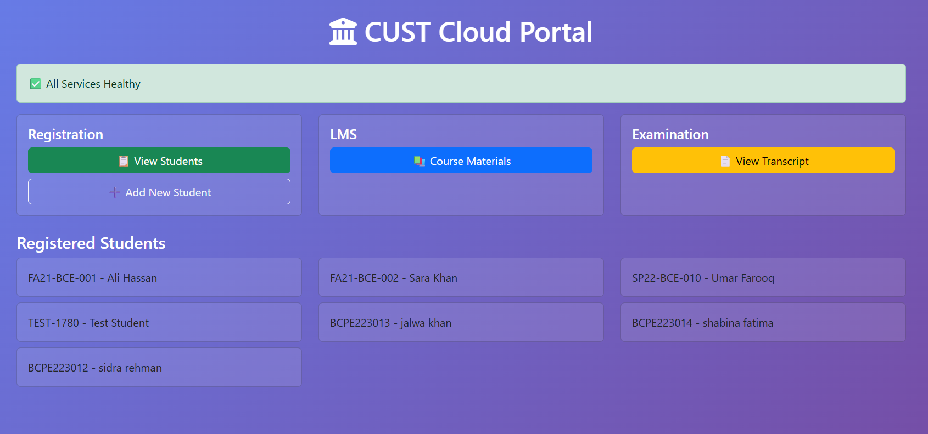
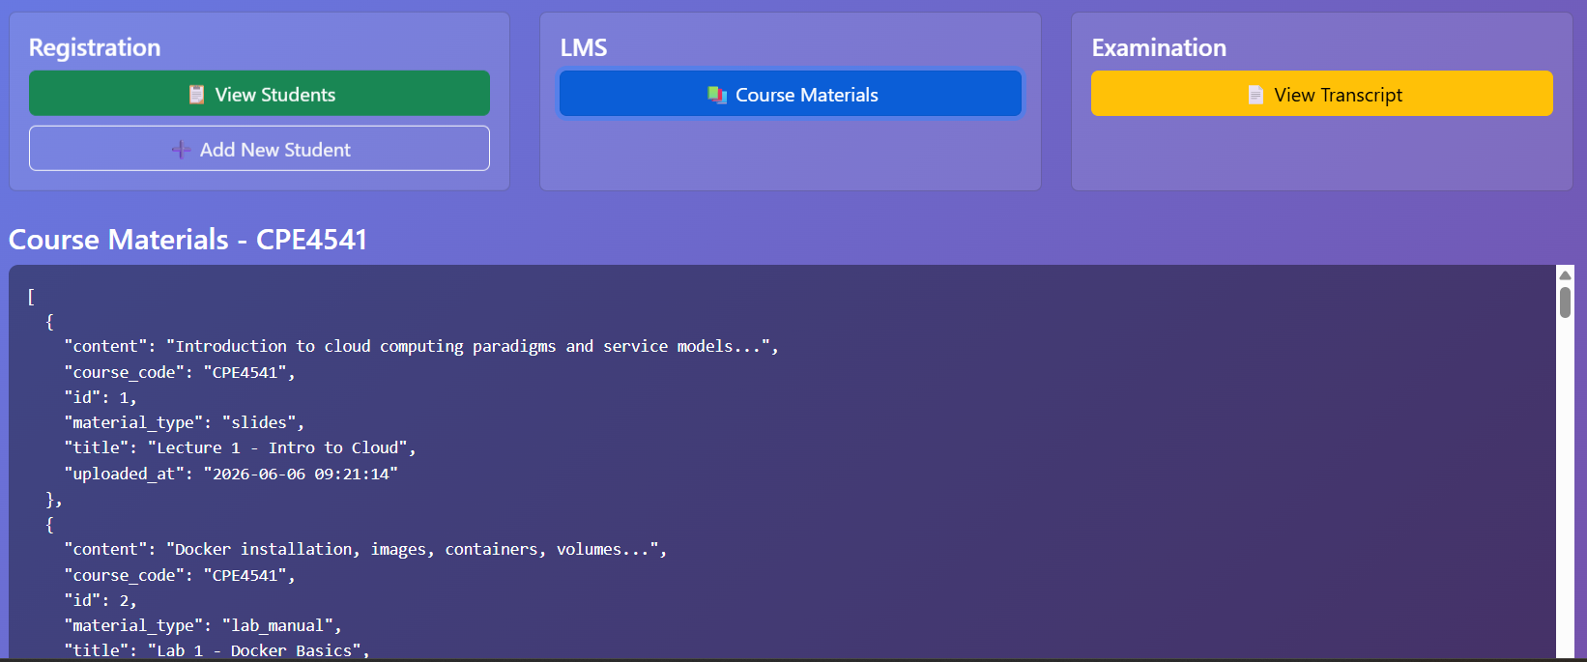
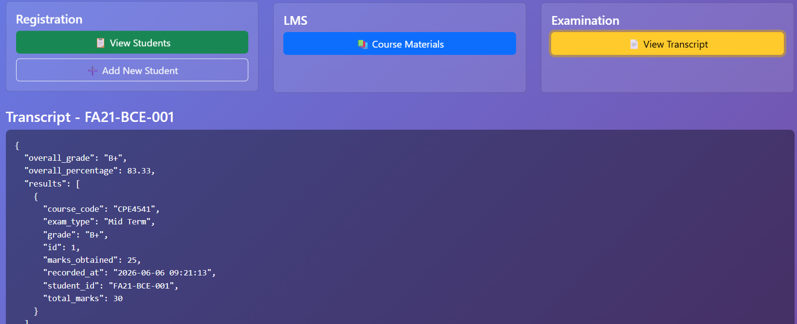
Build and Start all containers
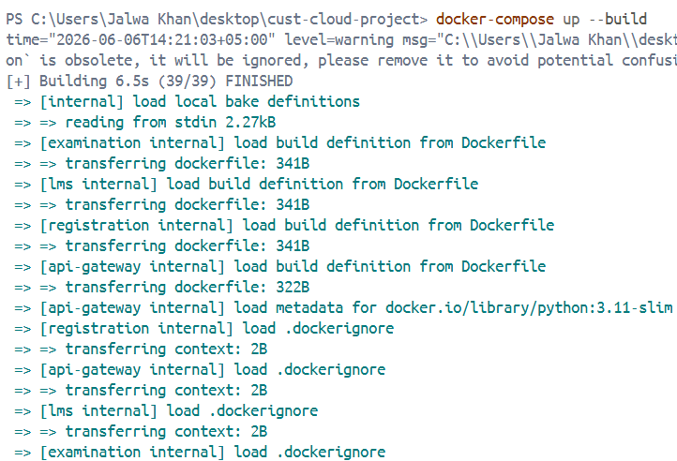
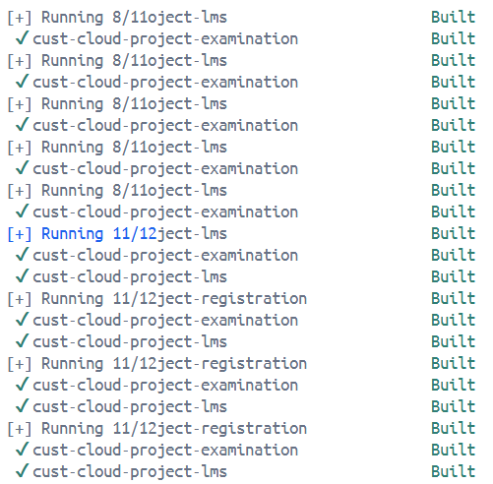
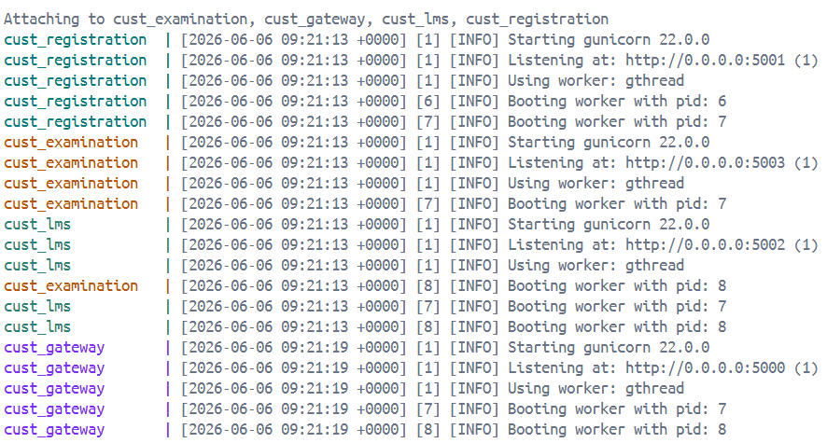
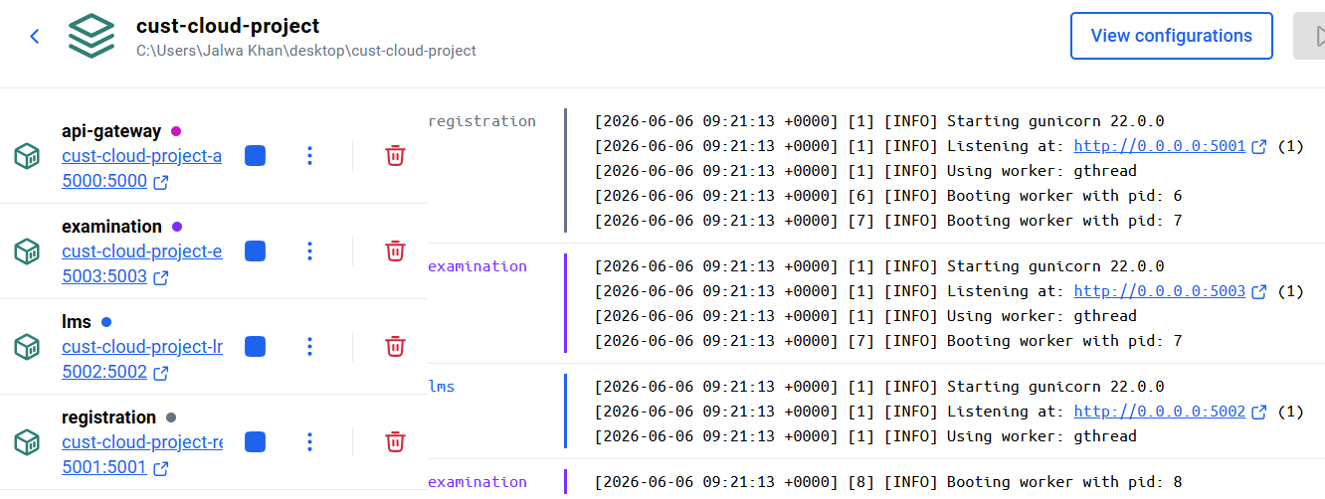
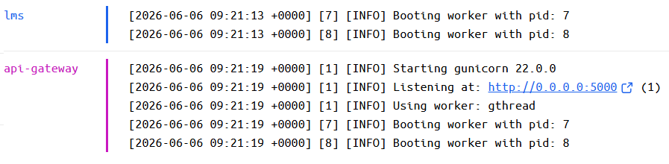
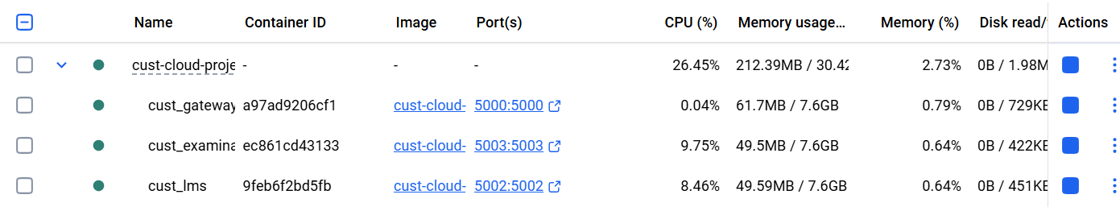
Verify everything is healthy
Open a second terminal in VS Code (Terminal → New Terminal) and run:
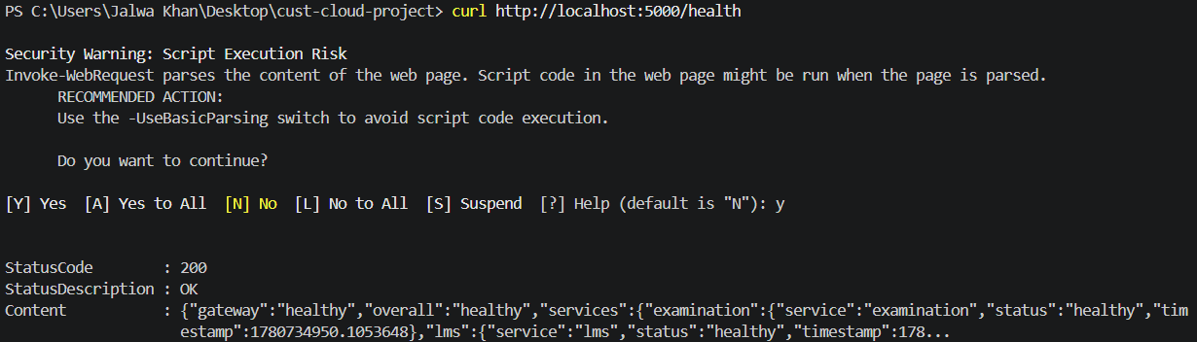
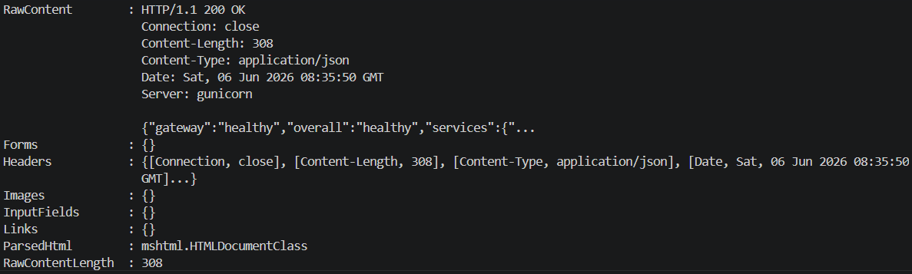
Test the services via browser
Open these URLs directly in your browser to see live data:
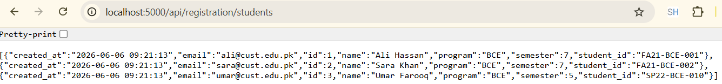
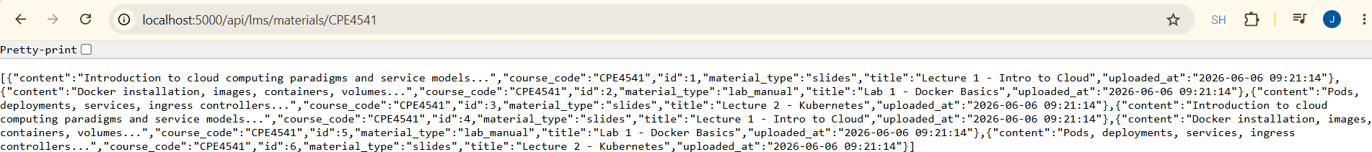
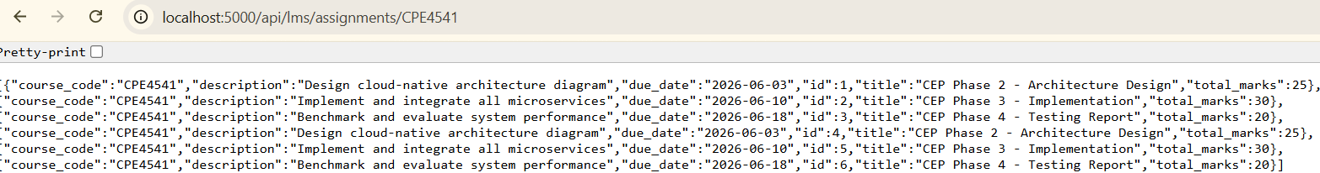
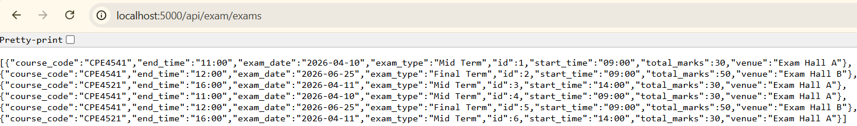
Run the distributed computing modules
Open a new terminal and run each module separately:
Multithreading demo (simulates 35 students registering simultaneously):
python distributed/multithreading/multithreaded_server.py
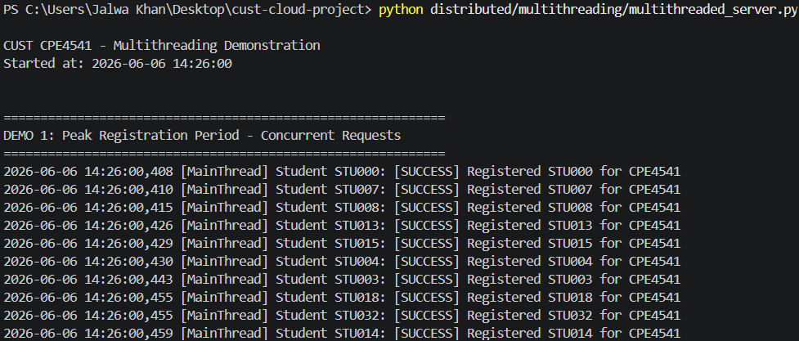
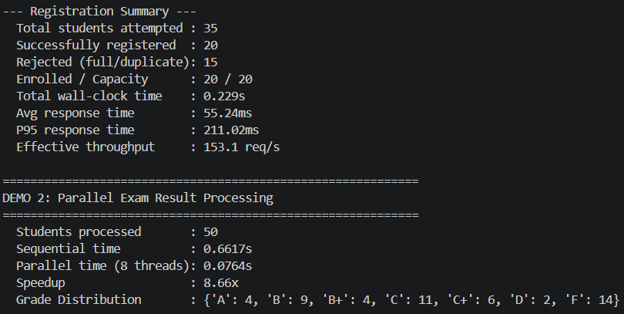
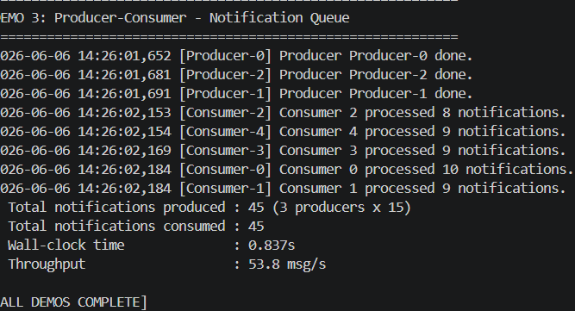
MPI grade processing (no MPI install needed — runs in simulation mode):
python distributed/mpi_prog/mpi_grade_processor.py
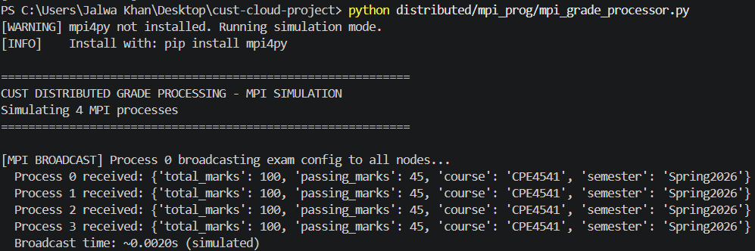
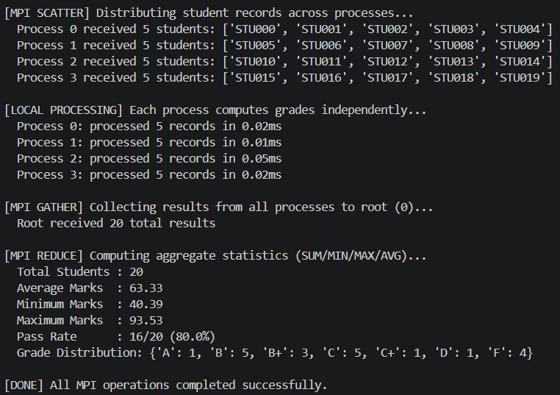

GPU benchmark (runs in NumPy CPU mode if no GPU):
python gpu/gpu_benchmark.py
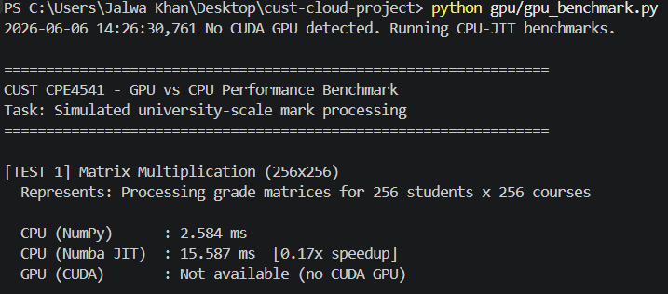
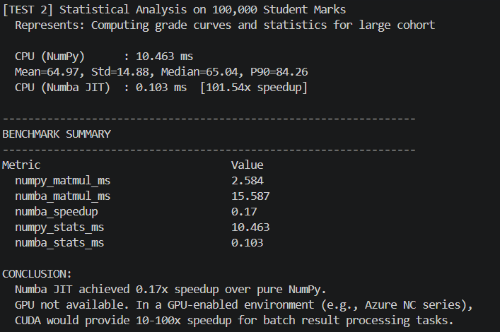
Socket server (open 2 terminals — one for server, one for client):
# Terminal 1
python distributed/socket_prog/socket_server.py
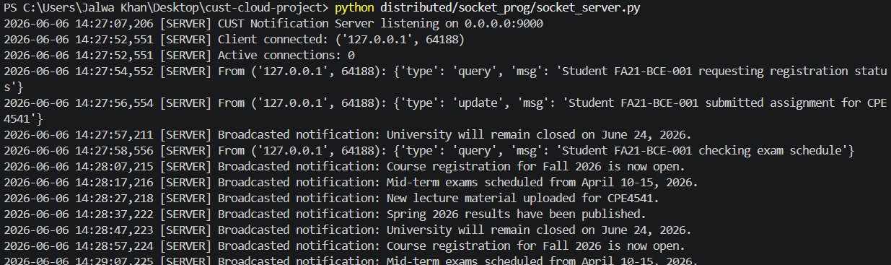
# Terminal 2
python distributed/socket_prog/socket_client.py FA21-BCE-001
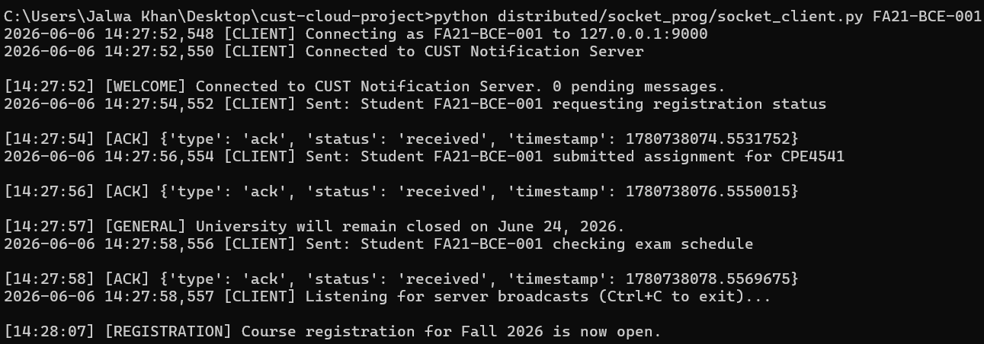
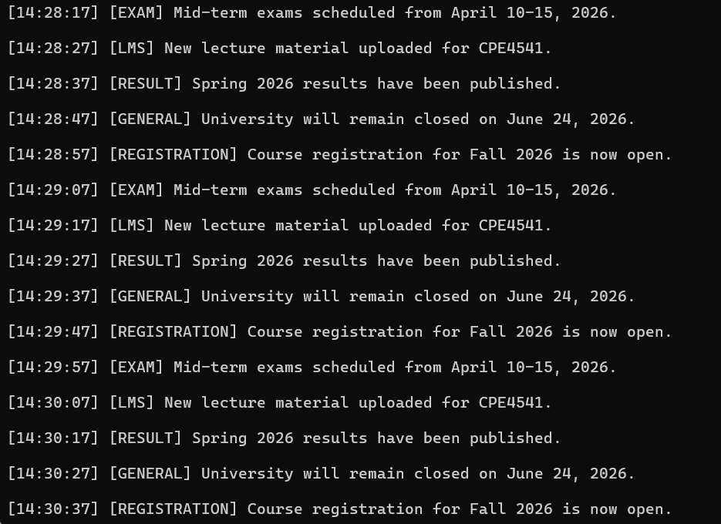
Run Phase 4 tests and benchmarks
With Docker still running, in a new terminal:
pip install requests
python tests/test_and_benchmark.py
